Subject: Programming with Java
Name – Shreya Panda PRN- 25070122181 CSE B3
ASSIGNMENT No: 9
Title
Write a Java program to demonstrate the use of the final keyword with variables, methods, and classes.

Problem Statement
Write a Java program to demonstrate the use of the final keyword with variables, methods, and classes.

Learning Objectives
- To understand the purpose of the final keyword in Java.
- To implement final variables, methods, and classes.
- To learn how final prevents modification and enhances program security.
- To understand the use of constants and immutable classes in Java.

Theory
The final keyword in Java is used to restrict modifications.
- A final variable cannot be reassigned once it is initialized.
- A final method cannot be overridden by a subclass.
- A final class cannot be inherited by another class.
Using the final keyword improves security, ensures data integrity, prevents accidental modifications, and makes programs more reliable. It is commonly used for constants, immutable objects, and classes that should not be extended.

Outcome
- Understood the use of the final keyword in Java.
- Learned how to declare final variables, methods, and classes.
- Demonstrated the implementation of final using practical examples.
- Improved understanding of secure and reliable object-oriented programming.

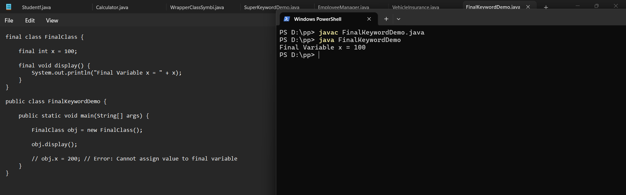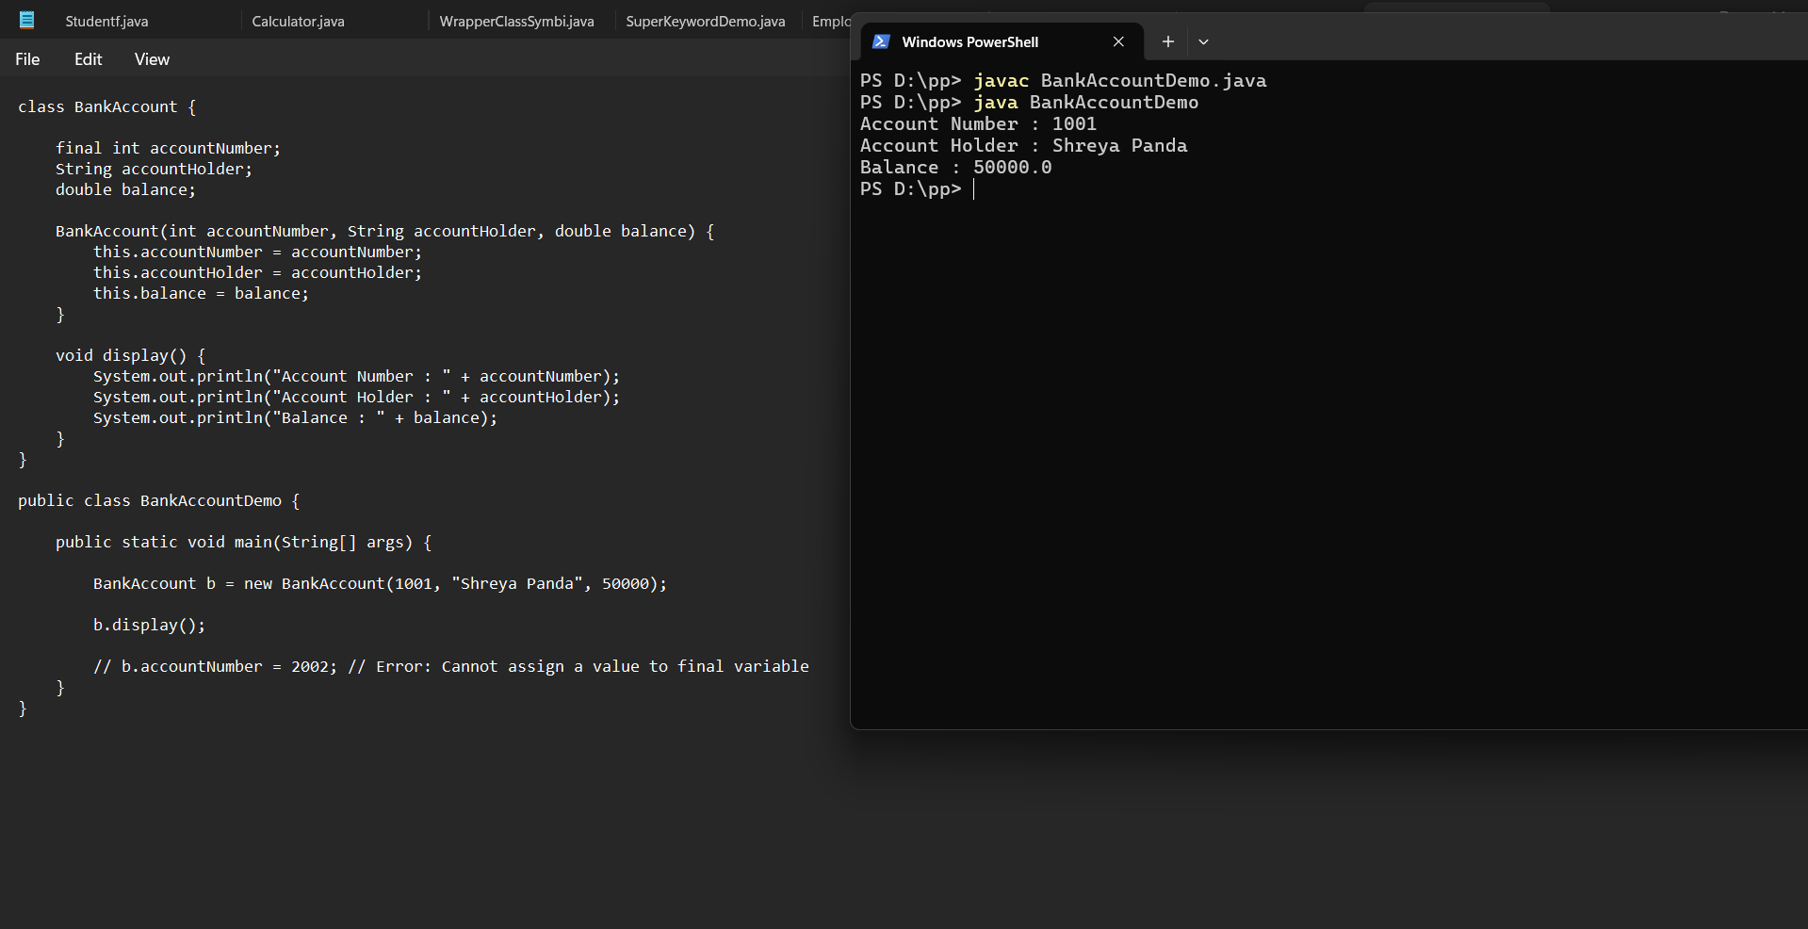
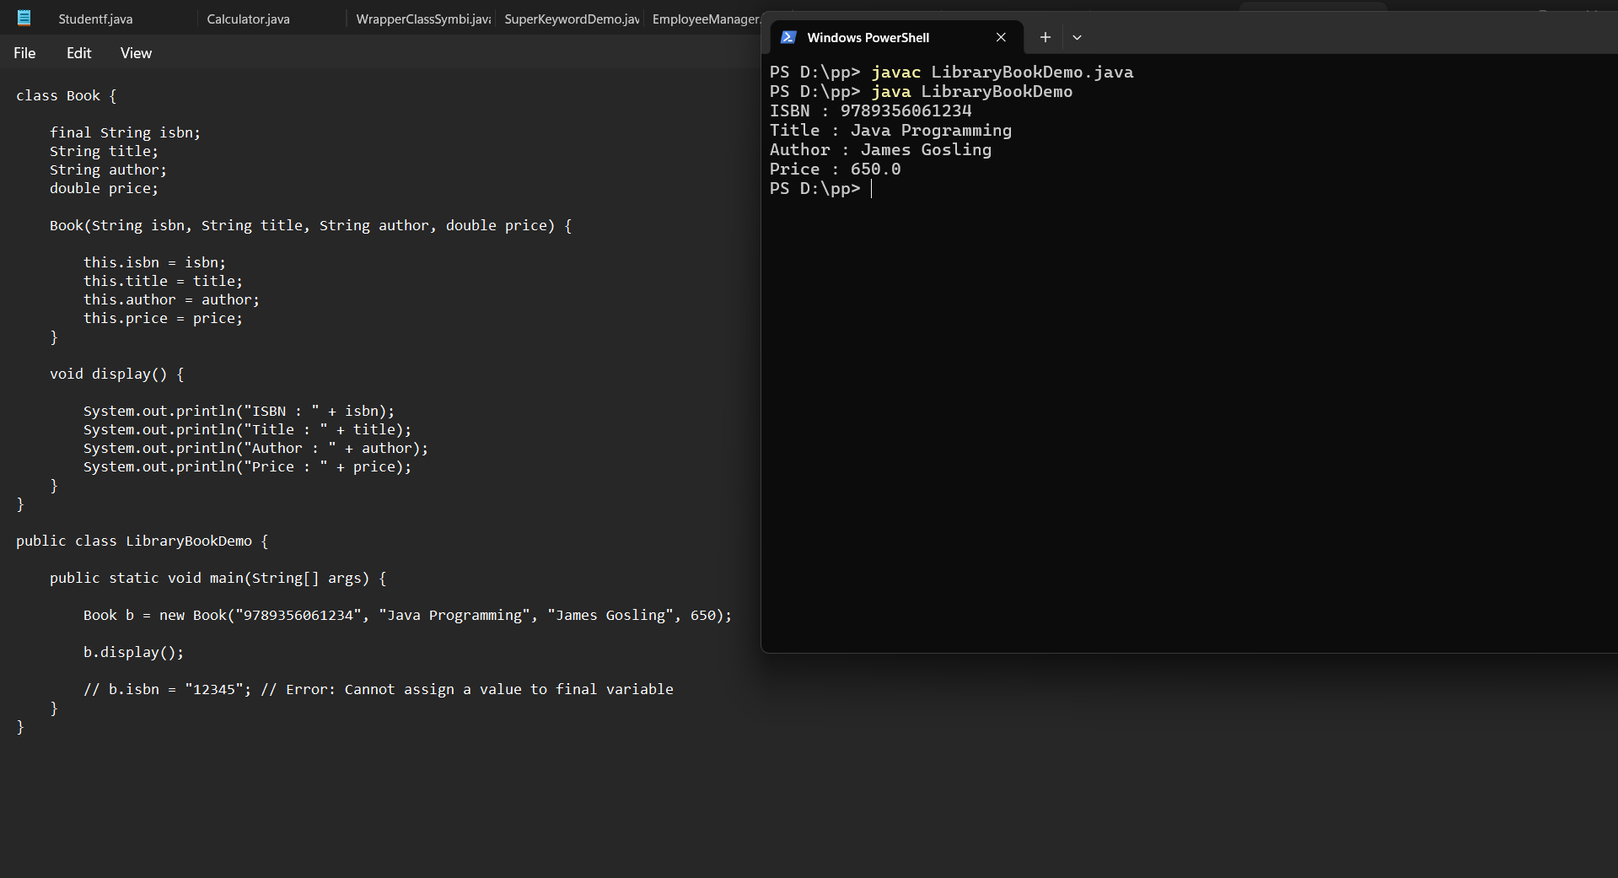
Conclusion
This assignment demonstrated the use of the final keyword in Java. It showed how final variables prevent reassignment, final methods prevent method overriding, and final classes prevent inheritance. These features help create secure, consistent, and maintainable Java applications by protecting important data and behavior from unintended changes.

